MIS 6326: Week 2 Assignments Report

Name: Mugizi Polycarp

Registration Number: 2024-M132-24001

Python script with the automated cleaning class (DataCleaner).

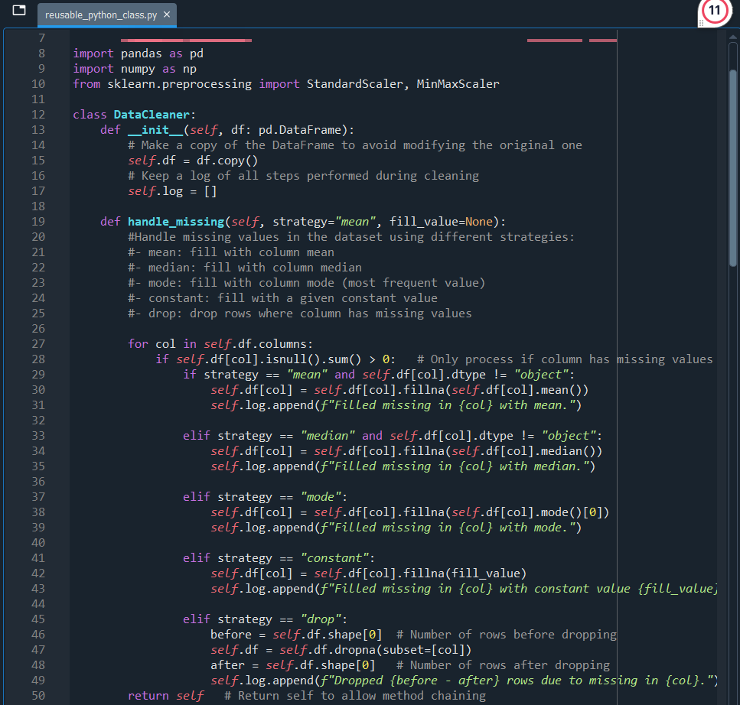
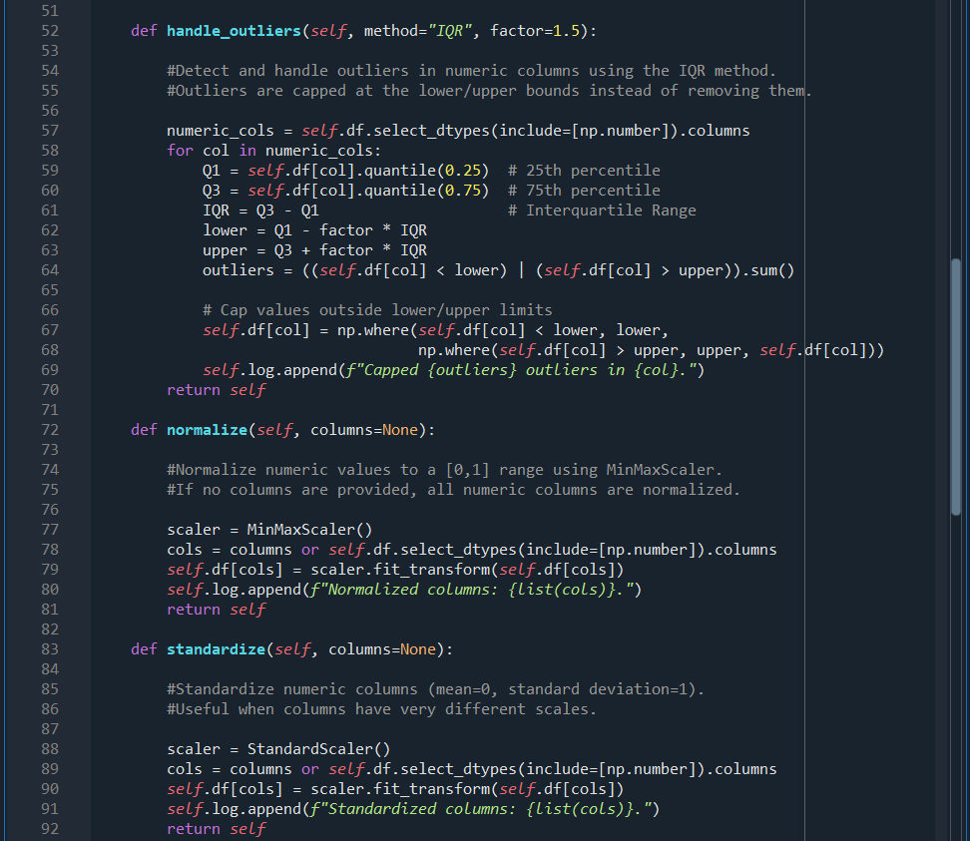
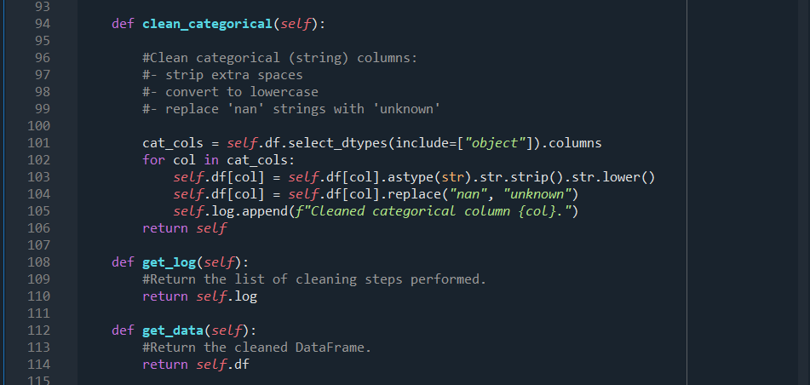

Cleaning dataset

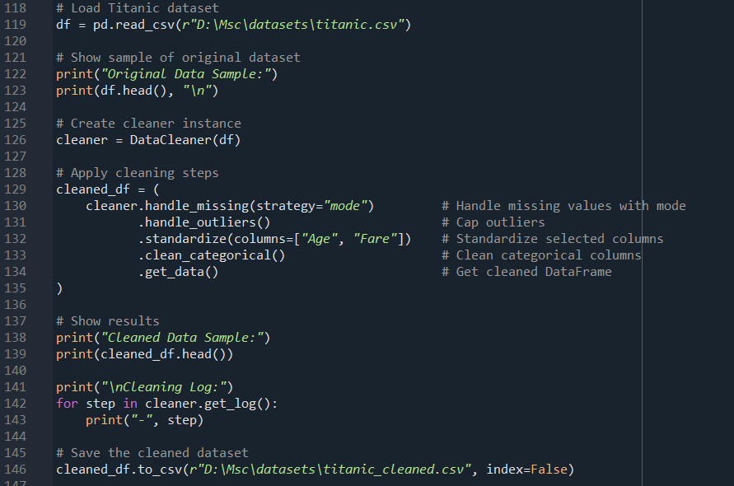

summary logs and cleaned dataset shapes for titanic

Log
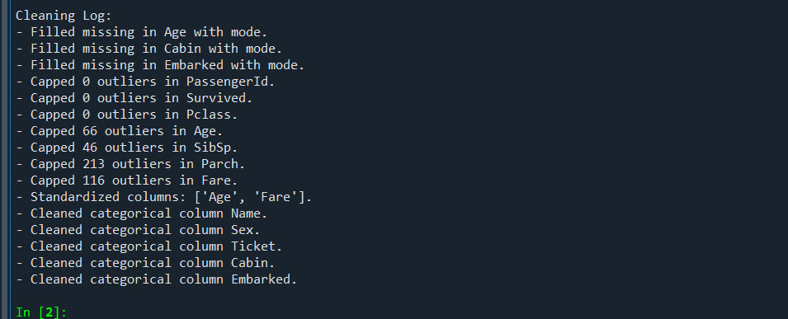

Cleaned dataset shape
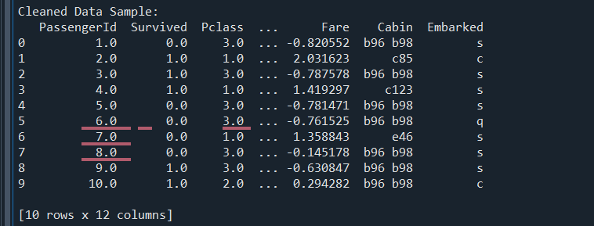

summary logs and cleaned dataset shapes for iris

Log
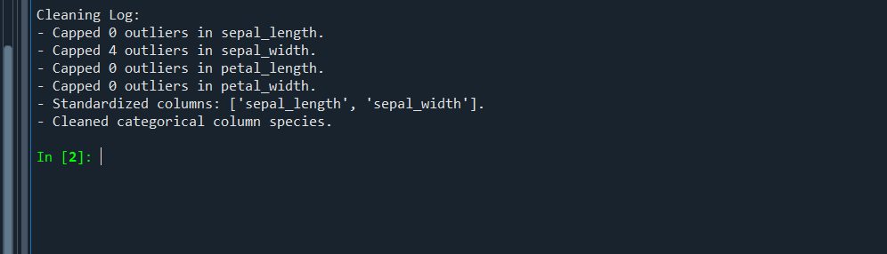

Cleaned dataset shape
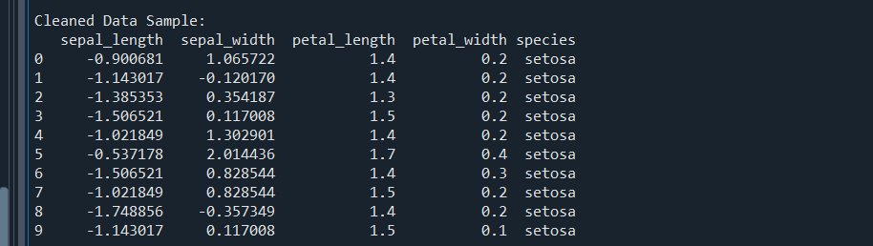

summary logs and cleaned dataset shapes for heart_disease

Log
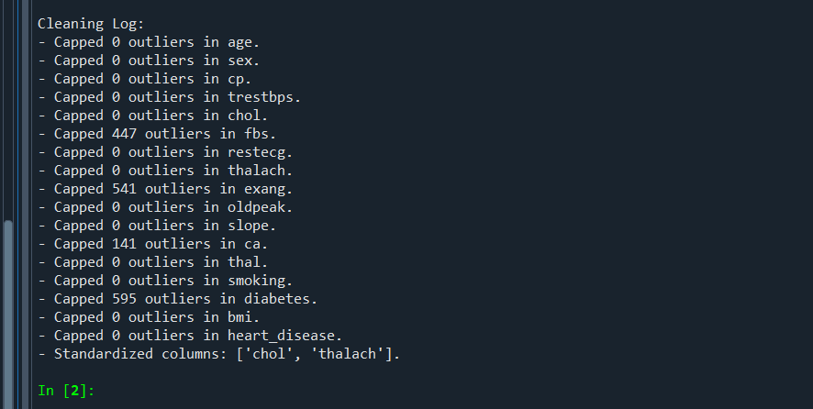

Cleaned dataset shape
